Go Native in Rappahannock Park!

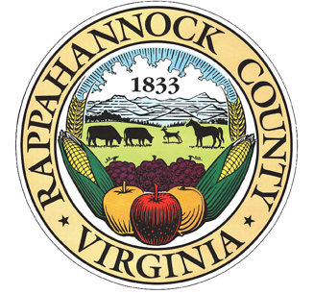
Second Saturday Park Workdays
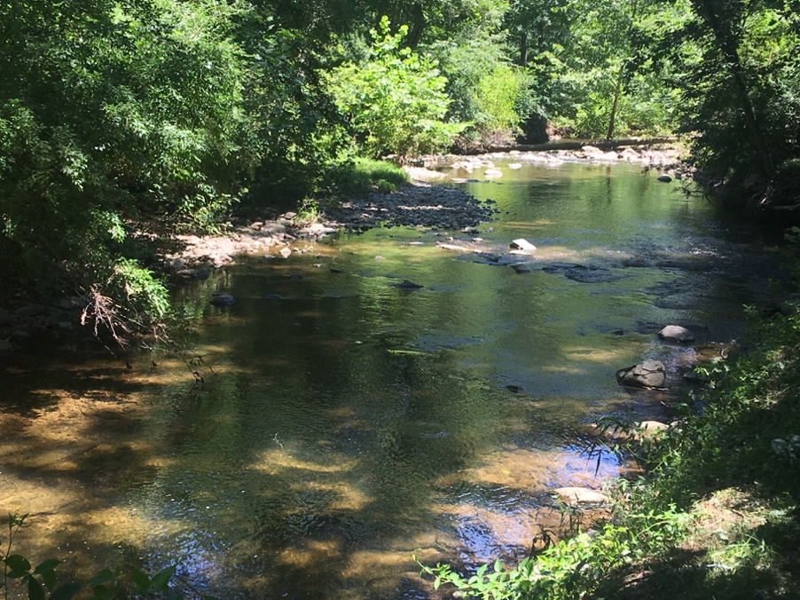
March 9: 9-12
April 6: 9-12

Directions:

7 Park Lane

On 211 across from exit for Little Washington.

www.rappahannockcountypark.weebly.com

During the past 6 months the park board has organized a concerted effort to
remove invasives and create an environment that welcomes existing and
future native plants.
*Rappahannock Park is approved for ORMN and Master Gardener volunteer hours.

Current projects include:
- Felling and removal of diseased or dead Ash trees
- Removal of ailanthus, Japanese honeysuckle, oriental bittersweet,
burning bush and other invasives from park perimeter
- Lining trails to the Rush River with cut sections of downed trees and
spreading woodchips on the trails

Join us on March 9 to continue this effort. We will focus on:
- Checking cleared areas for honeysuckle nubs
- Removing multi-flora rose, Japanese honeysuckle, bittersweet, burning bush, etc.
from forested area that has a bed of ferns which we can protect
- Noting any new native plant growth

Please join us! Bring your own heavy-duty gloves and loppers.

