The Rappahannock County Recreational Facilities Authority (RCRFA) was established by an act of the Board of Supervisors of Rappahannock County on November 2, 1978 and is governed by Chapter 47 of the Rappahannock County code.

A Master Plan has been approved which ensures that the Park facilities are designed and maintained in accordance with the mission and purposes set forth in the county code. The Master Plan outlines nine specific goals to achieve its mission, the eighth of which is educational outreach to local schools and the public. An aerial view of the Park is shown in Attachment 1. An overview of the areas earmarked for future development is shown in Attachment 2.

This document elaborates on six strategies the RCRFA has chosen for providing educational outreach to local schools and the public (Goal 8). These strategies are also tied to another RCRFA goal of demonstrating environmental stewardship through various projects and activities (Goal 7). The link between strategies for these two goals is discussed in this document.

The six strategies described below are not listed in any priority order. Most of these strategies are independent from one another and can be pursued in parallel. Some of the presentation / workshop strategies depend on installations and plantings. These strategies are designed to create and maintain sustainable native habitats, to provide educational opportunities to inform students and the public about natural resources, present and possible, in the Park; and to develop a cadre of volunteers to implement educational programs and applications in the Park and in the larger community.

**Goal: Demonstrate educational outreach to local schools and the public**

**Strategy 1:** Invite organizations to participate in various RCRFA outreach activities.

The RCRFA will actively invite other organizations to partner with and participate in various Rappahannock County Park outreach activities. Potential organizations which may be interested in collaborating with the RCRFA include, but are not limited to the following:

* Piedmont Environmental Council (PEC)
* Old Rag Master Naturalists (ORMN)
* Rappahannock Friends and Lovers of Our Watershed (RappFLOW)
* Rappahannock League for Environmental Protection (RLEP)
* Virginia Department of Forestry (VDOF)
* Culpeper Soil and Water Conservation District (CSWCD)
* Child Care Learning Center (CCLC)
* Rappahannock Electric Cooperative (REC)
* Friends of the Rappahannock (FOR)
* Blue Ridge Partnership for Regional Invasive Species Management (PRISM)
* Virginia Department of Game and Inland Fisheries
* Rappahannock Garden Club
* Master Gardeners (MG)
* Rappahannock public and private schools
* Trout Unlimited (TU)
* 4-H Club
* Boy and Girl Scouts
* Lions Club
* Knights of Columbus
* Clergy of Rappahannock
* Northern Virginia Astronomy Club (NOVAC)
* International Dark-Sky Association (IDA)

There are expected to be no costs associated with implementing this strategy.

**Strategy 2:** Invite collaborating organizations to participate in the removal and control of invasive species as part of educational outreach while creating a sustainable native environment in the Park.

* Remove and control invasive species (See Environmental Stewardship Strategies [Goal 7] document for detail on this process).
* Monitor plant health and implement treatments for disease and infestation (e.g. Emerald Ash Borer). Engage partner organizations to educate public. (See Environmental Stewardship Strategies [Goal 7] document for detail on this process).
* Schedule periodic volunteer workdays to involve County residents. The first event was held on Nov. 16, 2018 and March 9, 2019. The next events are planned for April 6, 2019 and subsequent monthly Saturdays. These work days are approved ORMN and Master Gardener volunteer projects for invasive removal, weed removal, and planting native gardens. They serve as a hands-on opportunity for participants to learn about native plants in the wooded and planted areas of the Park and also provide training in identification of and methods for removal of invasive plants. An ORMN, RLEP, MG, or RCRFA board member will lead this effort.
* Create study plots for monitoring the impact of invasive species. Two small plots were demarcated in May 2018 and cleared of invasive species by students in a local High School Horticulture class, to remove invasive species, and to observe and document native species that emerge in their place. Class fieldtrips are scheduled in 2019 for monitoring.

There are expected to be no costs associated with implementing this strategy.

**Strategy 3:** Invite collaborating organizations to participate in the planting of appropriate native species in designated cleared areas as part of educational outreach while creating sustainable native habitats in the Park that attract and support insects, butterflies, birds, and other wildlife. (See Environmental Stewardship Strategies [Goal 7] document for more detail on implementation strategies.)

The activities listed below serve to inform students and the public about native species; light, soil, and water needs of specific plants; the role of plants in preventing erosion; and the relationships between plant and animal communities.

* Engage a landscape designer to work with RCRFA and other partners (e.g. PEC, RappFLOW, ORMN, MG) to design a sustainable native plant community that provides habitat and opportunities for education and training.
* Plant trees and shrubs at Park entry on the VDOT right of way along Rt. 211 to provide a screen from highway traffic and from lighting from cars and nearby buildings at night.
* Plant flowers and shrubs along a proposed accessible walking path around the upper perimeter of the Park. Install signage to identify species located on the edge habitats along the wooded areas adjacent to the trail.
* Create native pollinator garden projects to inform and train students / public. The first octagonal raised bed was planted and mulched Nov. 16, 2018. It will be weeded and maintained by volunteers from RappFLOW, PEC, ORMN and MG. This plot should demonstrate not only native species but also become host to insects, butterflies, and birds.
* Locate and transplant native plants found in wooded and grass areas of the Park to other locations compatible with their needs. Volunteers on Park Workdays may collect data on plants observed and their locations. Workshops might train volunteers and students to identify plants and apply information about their light, soil, and water needs to decisions about where to transplant.
* Train community members to collect and propagate native seeds / plants. Participate in VDOF seed collection drives.
* Create a warm season grass / pollinator habitat under the REC power line right of way in collaboration with REC. This area will provide habitat for a variety of fauna as well as a learning lab for students and other observers in the community. This area might be a site for a milkweed Monarch monitoring project, an area for study and for citizen science participation through data collection groups such as University of Minnesota Monarch Larva Monitoring Project (MLMP).
* Establish and maintain healthy native plant environment along trails in wooded area and as a riparian buffer along the Rush River to demonstrate importance of plants in prevention of erosion and maintenance of water quality. Collaborate with the Headwater Stream Initiative (HSI) and Friends of the Rappahannock on best practices for aquatic health.
* Build a bluebird trail along perimeter and open trails. This will provide enjoyment, a resource for observation and study, and an opportunity for participation in citizen science data collection projects. Partner with Scouts, 4-H, RCHS shop class or other partners to build the boxes as a community project.
* Explore possibility of creating a garden or trail to exhibit Virginia Native Plant Society “Plants of the Year” as a way to educate students and public about important native plants in Virginia.
* Implement rain garden projects in low areas that collect standing water. Three potential areas have been identified.

The costs for landscape design, rain garden development, bluebird boxes, and plants will need to be covered by RCRFA’s annual fundraising and grants from various organizations. As of this writing, the RCRFA has applied for grants from the Krebser Fund (managed by the Piedmont Environmental Council) and RappFLOW to cover the costs for conducting a park survey, purchasing native plants, and shrubs and trees. Conversations with REC will continue regarding support for development of the REC right of way area.

**Strategy 4:** Schedule informational and hands-on presentations / workshops to inform students and the public about natural resources in the Park and about methods for sustaining healthy ecosystems on a large or small scale. As areas in the Park are developed, they can become site resources for workshops related to the flora, fauna, and ecosystem features of each area.

* Install appropriate low-key interpretive signage on trails and pollinator gardens. RCRFA may collaborate with RappFLOW to design interpretive signage while PEC may assist in obtaining cost estimates for design and installation.
* Install new permanent interpretive display panel at the pavilion providing information on outreach events and environmental topics of interest.
* Develop use of Rappahannock Park website and Facebook page to communicate about events and projects at the Park as well as to provide links to articles of interest regarding natural habitat protection.
* Expand use of local media and social media to increase visibility regarding events and projects at the Park.
* Lead ‘tours’ of projects and developed areas in the Park with emphasis on support of native species and ecosystems.
* Use remaining and hopefully dwindling specimens in Park for presentations and workshops to instruct community members regarding options for identification and removal of invasive species and to inform community members of native species which may replace invasives and support eco-health. A “scavenger hunt” activity may be developed by which students and interested members of the public may discover native and invasive plants (using Most Unwanted posters) in the areas in which they occur naturally. This type of activity could serve as informal public education as well as provide the framework for workshops designed to instruct in the effects of invasive species, their identification and removal.
* Lead presentations and workshops using Native Plant Garden, wooded area, river and riparian edge, and meadows to explore the role of native plants in support of other native species.
* Coordinate with RappFLOW and ORMN to lead stream monitoring and water quality trainings and workshops using Rush River sites.
* Coordinate with Virginia Department of Game and Inland Fisheries, PEC, and other community organizations to provide activities to foster an interest in fishing, and healthy fish habitat.
* Coordinate with PEC to involve other organizations to organize an annual Conservation Day with information sessions and activities to educate and support conservation efforts.
* Coordinate with local schools and partner organizations to lead workshops with youth to engage their involvement, interest, and commitment to natural resources. (Current connection with RCHS Horticulture class and with Childcare and Learning Center)
* Use community events like Free Fishing Day to support Park objectives for teaching skills that encourage enjoyment and understanding of the natural world. In June 2019, Free Fishing Day will include free loan of fishing equipment and instruction, water monitoring (RappFLOW), and stream macro-invertebrate monitoring (ORMN).
* Organize and lead other activities as Park plan develops. The Park is currently the launch-site for the Rappahannock North American Butterfly Count. As these natural areas in the Park are developed, the Park may become a site for presentations, workshops, and organized community events like Bird Counts; Plant / Pollinator Studies, and Acorn / Seed Collection.

There may be costs associated with signage and advertising for events. These costs will need to be covered by RCRFA’s annual fundraising and grants from various organizations. Grant applications described under Strategy 3 will also cover these costs.

**Strategy 5:** Offer events to promote appreciation of Rappahannock’s dark skies.

Host at least four ‘dark sky events’ at the Park each year to maintain the Silver Tier Dark Sky Park designation from the International Dark-Sky Association. These events will be held in collaboration with RLEP, interested astronomy clubs and local public and private schools. The Park is open to the public after dusk for astronomical use provided individuals and groups follow agreed park reservation/notification protocols.

Explore the possibility of Full Moon Sky Observation and Hikes in the Park. The Park would remain open for this event as during the Dark Sky Park events.

There are expected to be no costs associated with implementing this strategy.

**Strategy 6:** Explore potential use of Park habitats for research.

One possibility is to present the Park as a potential research site to institutions which might apply for a Virginia Native Plant Society (VNPS) research grant, e.g. Smithsonian Conservation Biology Institute, college and university departments in the region.

There are expected to be no costs associated with implementing this strategy.

Attachment 1: Aerial View of the Rappahannock County Park

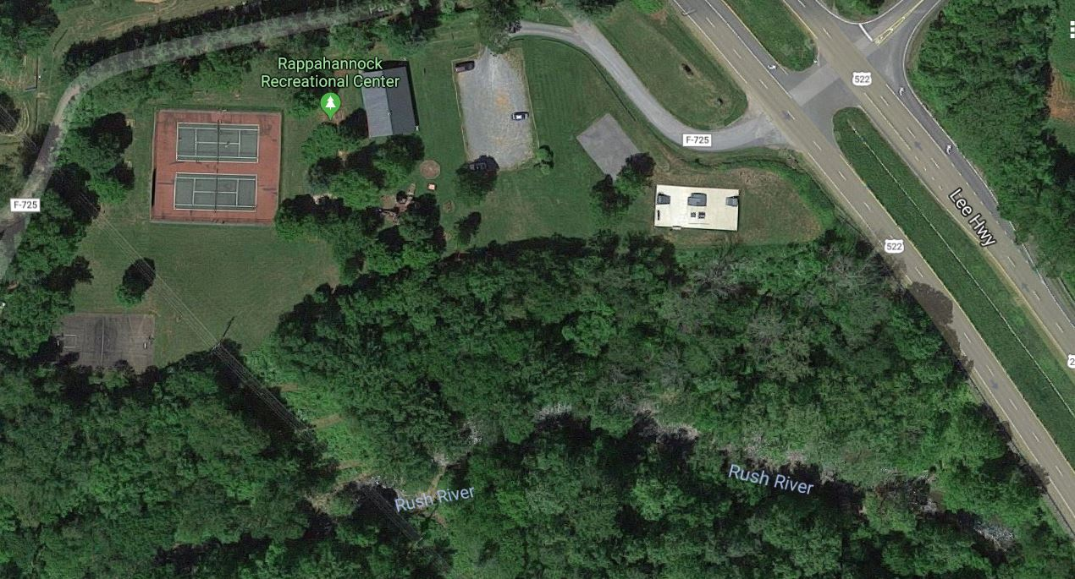

Attachment 2: Areas Earmarked for Future Projects

Jan 31, 2019



Attachment 3: Areas Earmarked for Clearing and Planting

Jan 31, 2019

