Rapp Park Authority Gets New $1K Grant for Pollinator Garden

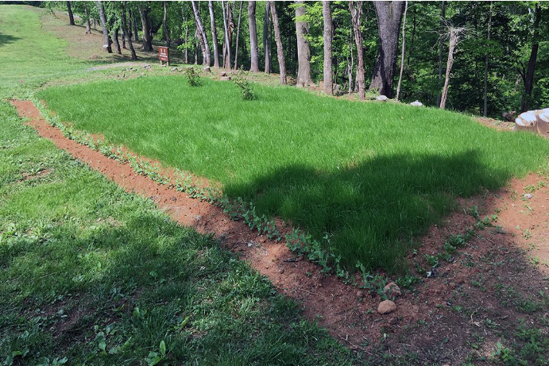
By Chuck Jackson Staff Journalist (BRI)
Providing the public with a new pollinator garden at the Rappahannock County Park where “native and beautiful” plantings can illustrate both the beauty of native plants as well as their importance to the survival of native insects, butterflies, bats, birds and other wildlife species, has reached reality thanks to a grant from the Keep Virginia Beautiful “30 in 30 Green Grants”.
Rappahannock County Recreational Facilities Authority learned Monday it received one of 30 grants presented each day in June, to “deserving government, non-profits, civic and service organizations in the Commonwealth. The grants provide money for improving the natural and scenic environment through five impact areas: Litter Prevention, Waste Reduction, Recycling, Beautification, and Environmental Education.
The Authority has called a special meeting for members for 9 a.m., Saturday, to discuss which plants they should use for the garden. Workdays also have been scheduled Saturday, July 27 and August 4, 2019 for the actual plantings.
Per grant guidelines, the project must be completed by October 1. The authority asked and received $1,000 for the pollinator garden. It could have received a minimum of $500 or $750.
According to Authority member Torney Van Acker, the funds will be used to purchase native plants for a new pollinator garden. “We hope to source the plants from local growers,” Van Acker said Monday in a telephone interview. “The plan is to use the pollinator garden for outreach activities.” He added the Authority hopes drawing schools and community groups to use the park as an educational resource that may expand the use of native plants to other private and public lands in the county.
“The local schools are already engaged with the Park in invasive/native species initiatives,” Van Acker said. “We want to expand the use of the Park for citizen-science activities, such as the North American Butterfly Count, which currently uses the Park pavilion as a meeting place to launch the event but does not yet use the Park as a site for observing butterflies.
“The new garden is situated to be visible from the pavilion, parking lot and playground area and will hopefully lure people using those areas to explore the natural areas of the Park.” Van Acker reports the garden will be the first stop of a planned handicapped-accessible pedestrian pathway that will circle the edge of the upper cleared area and added county non-profit RappFLOW, might provide the Park with interpretive signage like they’re already doing for the octagonal garden.

