Go Native in Rappahannock Park!

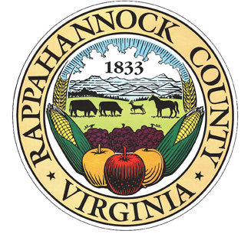

Next Monthly Workday in Park:
June 22: 9AM-12 noon
*Rappahannock Park is approved for ORMN and Master Gardener volunteer hours.

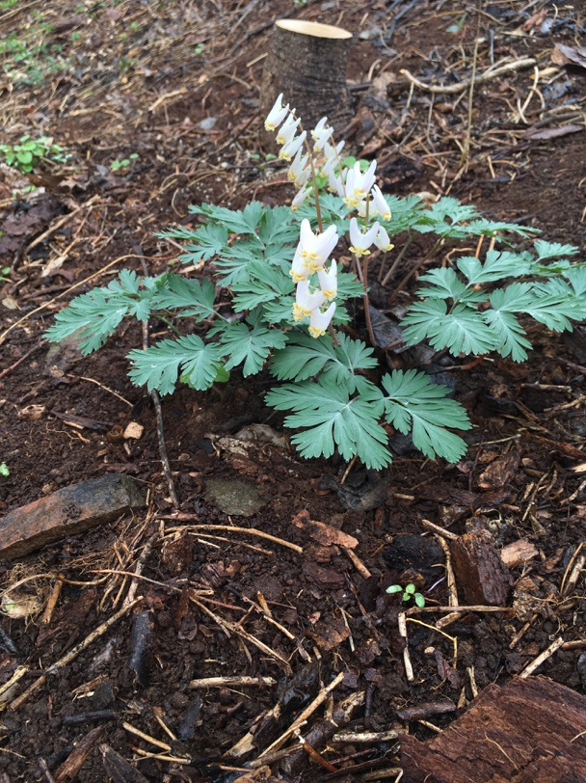
Onward!

So far:
Ferns:
Christmas fern, ebony spleenwort, wood fern, hayscented fern
Flowers: bloodroot, toothwort, spicebush, corydalis, Dutchman’s breeches, mayapple, Blueridge carrion flower, Virginia waterleaf, lyreleaf sage, Canada black snakeroot, blackhaw, coral berry
Emerging trees: hickory, oak, sugar maple, ash, pawpaw
Coming attractions: xxxx
Check website for photos.

Please join us! Bring your own heavy-duty gloves, clippers and loppers.
On our June workday, we will continue to
- battle garlic mustard, honeysuckle, and English ivy
- weed and sort plant labels in native plant garden
- identify any new plants emerging
Directions:
7 Park Lane
On 211 across from exit for Little Washington.
www.rappahannockcountypark.weebly.com

