Go Native in Rappahannock Park!

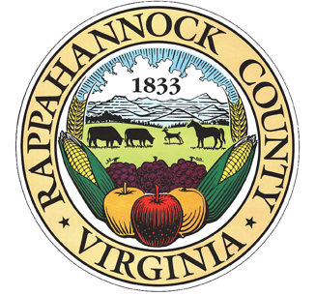
Monthly Saturday Park Workdays
April 6: 9-12
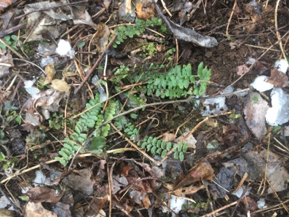
May 18 : 9-12

Directions:

7 Park Lane

On 211 across from exit for Little Washington.

www.rappahannockcountypark.weebly.com

During the past 9 months the park board has organized a concerted effort to
remove invasives and create an environment that welcomes existing and
future native plants.
*Rappahannock Park is approved for ORMN and Master Gardener volunteer hours.

Join us on April 6 to Free the Ferns!

We have uncovered a bank of ferns along the trails. The more we clear the
more ferns we discover.
So far: Christmas fern, ebony spleenwort, and wood fern.

We will also:
- Check cleared areas for persistent honeysuckle nubs
- Watch out for garlic mustard, chickweed, ground ivy, and English ivy
- Note and catalog any new native plant growth

Please join us! Bring your own heavy-duty gloves, clippers and loppers.

